Atomic Project

**Profile Picture**

**Profile Picture**

**Step-1: User Story**

* As a user I want to add my customer’sprofile picture in my website so that this will show on the site. (C)
* As a user I want to edit profile picture so that I can change it if necessary. (U)
* As a user I want to view the profile picture. (RS)
* As a user I want to soft-delete my profile picturefrom the website so that I can recover it.
* As a user I want to recover my soft-deleted profile picturefrom trash list.
* As a user I want to delete profile picture from the website. (D)

**Step2: Use Case**

**Add profile picture:**

|  |  |  |
| --- | --- | --- |
| **Requirements** | **Key Features** | **Acceptance Criteria** |
| As a user I want to add my customer’s profile picture in my website so that this will show on the site. | To make a user friendly, Data should be saved without refreshing page. (Ajax) | 1.    User can add profile picture without any problem.(Core features)  2.    User should see the success/failure message. (Message)  3.    User can upload only picture (Format Validation)  4.    No empty value is accepted.(Empty Validation)  5.    In case of invalid input JavaScript message should be displayed. (Usability/User Friendly Interface)  6. User wants to reset form content anytime. |

**Edit profile picture:**

|  |  |  |
| --- | --- | --- |
| **Requirements** | **Key Features** | **Acceptance Criteria** |
| As a user I want to edit profile picture so that I can change it if necessary. | To make a user friendly, Data should be saved without refreshing page. (Ajax) | 1.     User can edit profile picture without any problem.(Core features)  2.     User should see the success/failure message. (Message)  3.     User can upload only picture (Format Validation)  4.     No empty value is accepted.(Empty Validation)  5.    In case of invalid input JavaScript message should be displayed. (Usability/User Friendly Interface)  6. User wants to reset form content anytime. |

**View profile picture:**

|  |  |  |
| --- | --- | --- |
| **Requirements** | **Key Features** | **Acceptance Criteria** |
| As a user I want to view the profile picture. |  |  |

**Soft-Delete profile picture:**

|  |  |  |
| --- | --- | --- |
| **Requirements** | **Key Features** | **Acceptance Criteria** |
| As a user I want to soft-delete my profile picturefrom the website so that I can recover it. |  | 1.    Confirmation message should be displayed.  2.    After successfully soft-delete a message should be displayed. |

**Restore profile picture from trash list:**

|  |  |  |
| --- | --- | --- |
| **Requirements** | **Key Features** | **Acceptance Criteria** |
| As a user I want to recover my soft-deleted profile picture from trash list. |  | 1.    Confirmation message should be displayed.  2.    After successfully recover a message should be displayed. |

**Delete profile picture:**

|  |  |  |
| --- | --- | --- |
| **Requirements** | **Key Features** | **Acceptance Criteria** |
| As a user I want to delete profile picture from the website. |  | 1.    Confirmation message should be displayed.  2.    After successfully deletion a message should be displayed. |

**User Friendly Navigation:**

|  |  |  |
| --- | --- | --- |
| **Requirements** | **Key Features** | **Acceptance Criteria** |
| As a user I want to have user friendly navigation so that I can browse the site easily. |  | 1.    There should be one button at the bottom of add form. (A. File Upload)  **A.** User should see the profile picture if clicked on “File Upload” button.  2.    User should see the profile picture after edit/update info.  3.     User should stay on the page of a site after deleted profile picture. |

**Step 3: Robustness Diagram**

**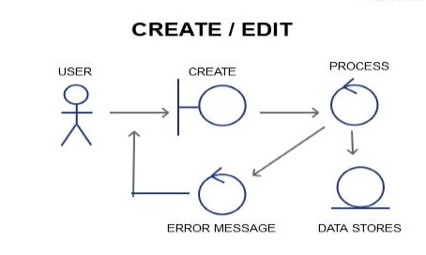**

**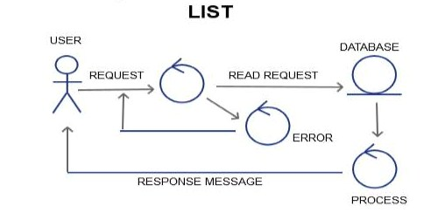**

**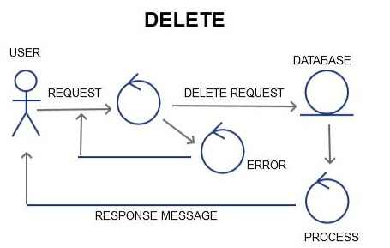**

**Class Diagram:**

**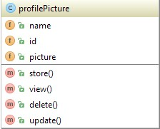**

**Sequence Diagram:**

**Create/Add/Edit**

**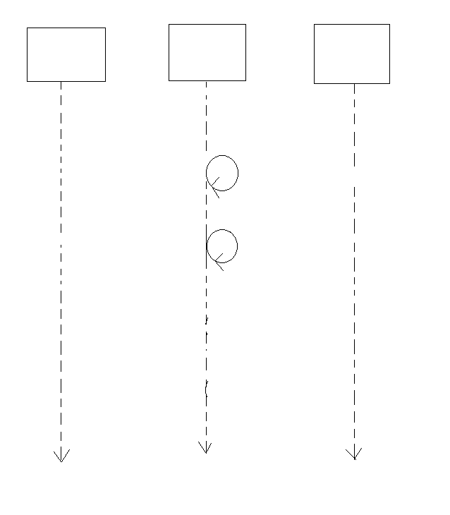**

Storing Data to DB

Empty Validation

Format Validation

Add Request

Response Message

Validation failure

DATABASE

PROCESS

USER/GUI

**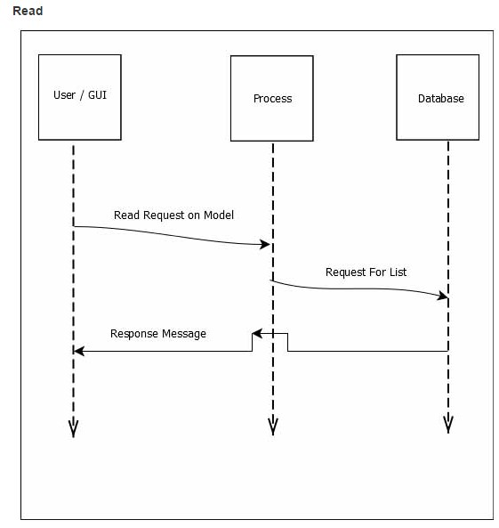**

**Delete**

**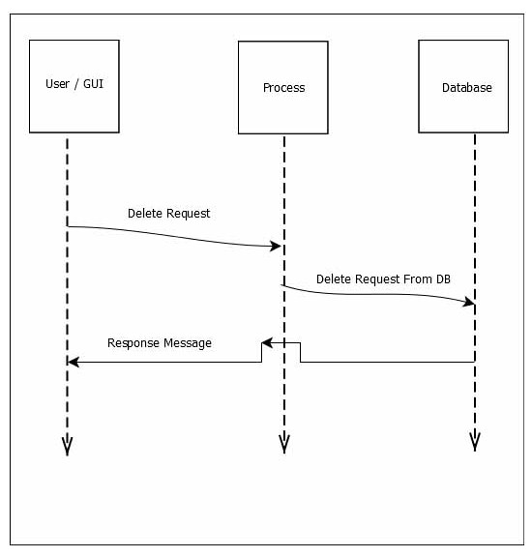**

#### Schema Diagram:

#### F:\xampp\htdocs\atomic_project_rumpa_136509_b34\Atomic project b34\Schema diagram\profilepicture.JPG

#### Mockup:

#### Add:

#### 

#### Edit:

#### 

#### View:

#### 